Feast of St. Brigid, 1st February 2021

Greetings on this special Feast of St. Brigid.

Many of us are familiar with holy wells around the Country. Many of these wells are dedicated to St. Brigid. The best know are those in Faughart, the place of her birth and Kildare, the location of her Monastery.

All these wells have in common their association with healing. Brigid’s special gift was that of healing.

The Covid Pandemic has brought into focus our susceptibility and vulnerability as well as our human limitations in the face of this death-dealing virus.

It may be an appropriate time to renew our friendship and our love of our second Patron Saint. There is a call to prayer for healing in our Country and for our Sisters and Brothers around the world. Some of us are familiar with a custom associated with the Brat Bride (Brigid’s cloak).
On the eve of Brigid’s Day every household placed a piece of cloth or a scarf outdoors, on a hedge or on the grass. It was understood that Brigid would touch the ‘Brat’ as the dew (or the rain) fell. That cloth would “hold” her healing touch throughout the following year and was held close at times of illness, or for a safe birth of a chid or of an animal.

Our ancestors were tuned into the presence of mystery in the dew, in the wells, in the sunrise, in the fire and the woods and in the fields. Our planet is imbued with the Divine. “Finding God in a leaf” is an expression of our reconnecting with that spirituality.
Let us renew our commitment to healing the Planet and pray that our suffering Sisters and Brothers will be part of that healing process.

For this we entreat our Saint who heralds the arrival of Spring and new life : St. Brigid pray for us.

Faoi Bhhat Bride sinn.

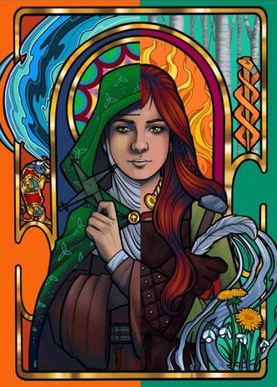
Gra agus Beannachtai

Nellie

